System design

Layered Architecture

1. Overview

The system uses a layered architecture to find the shortest path between a start and destination in a campus grid (matrix). It applies algorithms like Breadth-First Search and Dijkstra's Algorithm.

2. Architecture Layers

Presentation Layer → Controller Layer → Service Layer → Data Layer

Layered mapping:

User
↓
Presentation Layer (UI)
↓
Controller Layer (validate request)
↓
Service Layer (Engine → BFS/Dijkstra)
↓
Data Layer (Grid / Matrix)
↓
Service Layer (buildPath)
↓
Presentation Layer (Output)

3. Layer Responsibilities

Presentation Layer (UI)
- Takes input (start, destination)
- Displays path result

Controller Layer
- Receives request from UI
- Validates input

Calls service layer
- Service Layer (Core Logic)
- Runs pathfinding algorithms:
- Breadth-First Search (unweighted)
- Dijkstra's Algorithm (weighted)
Reconstructs final path

Data Layer
- Stores grid as matrix:
- int[][] grid;
- Manages obstacles and weights

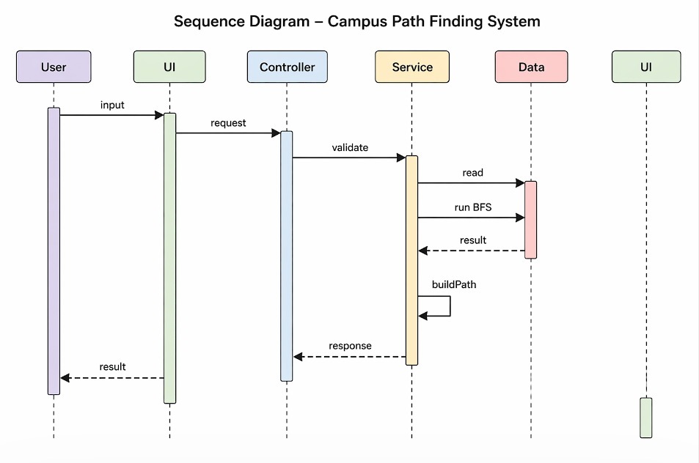

4. Workflow

User enters start & destination
Controller validates input
Service layer runs algorithm
Path is computed and reconstructed
Result is displayed in UI

5. Key Benefits

Simple and easy to understand
Clear separation of logic
Easy to maintain and extend

6. Future Scope

Add weights (traffic)
Improve UI visualization
Extend with advanced algorithms

